

fundamental of computer programming

LAB_11



November 29, 2024

**HANAN MAJEED**

**CMS:519166**

**Task A:**

Write a modular program that takes two 3x3 integer matrices as inputs from a user and calculates their product. The multiplication process is provided below.



**Input:**

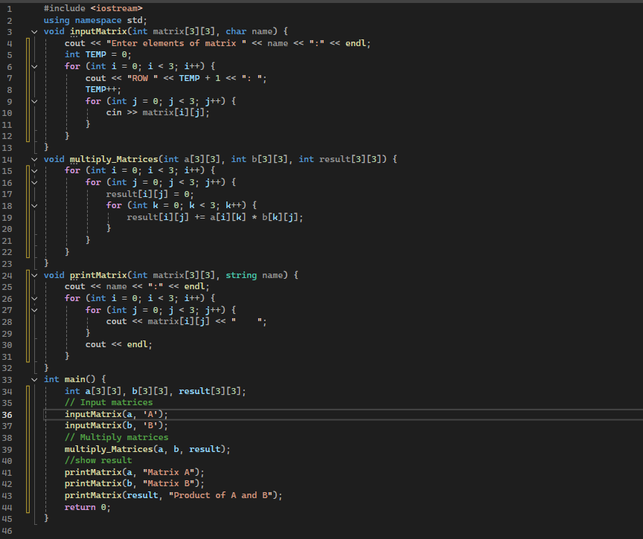

**Output:**

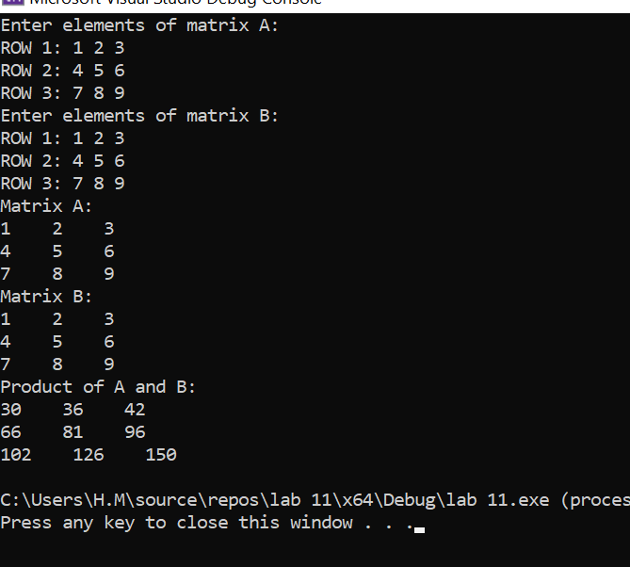

**Task B:**

Thresholding is the first step in any image segmentation technique. Write a C++ program that initializes an image matrix of size 10x10 with pixel intensity values ranging from 0-255 (using the rand() function). It then computes the average of all values and uses it as a threshold to generate the binary image. The program should display the initial image matrix, threshold value, and the binary image matrix.

Note: All values less than or equal to the threshold become 0 and all values greater than the threshold become 1.

**Input:**

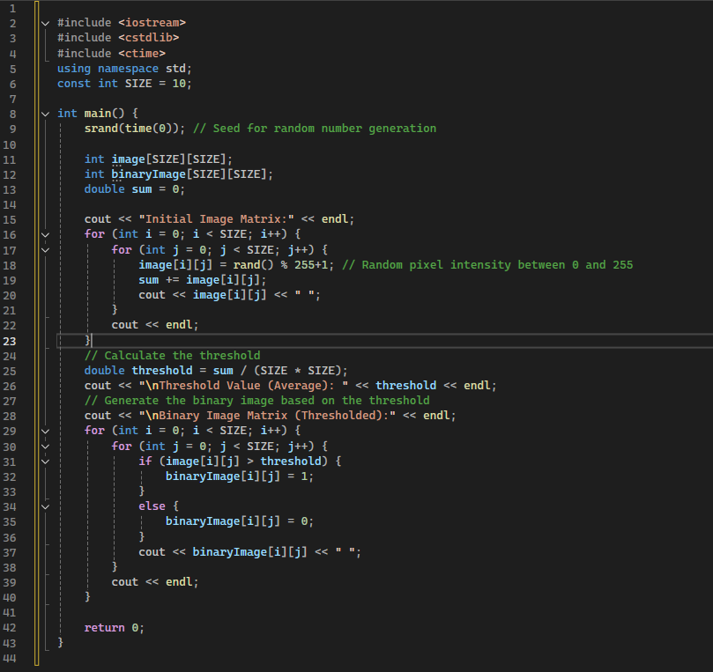

**Output:**

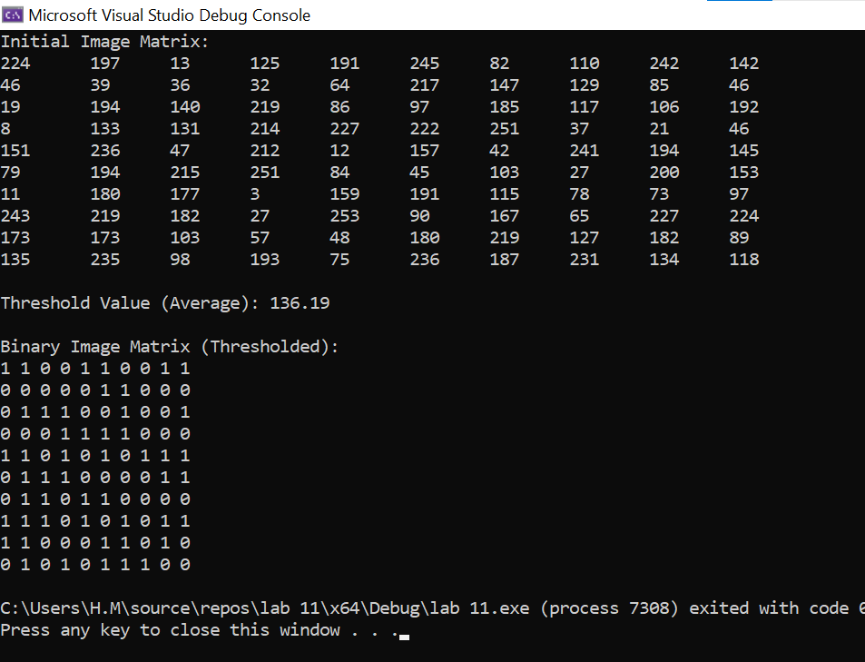

**Task C:**A cricket ground has a seating arrangement represented by a 2D array of size 10x10, where each element corresponds to a seat. Initially, all seats are unoccupied (represented by 0). Write a modular program that allows users to:

1. View the current seating arrangement.
2. Book a seat. The user can enter the row and column of the desired seat. If it's available, mark it as booked (1). If it's already booked, inform the user.
3. Cancel a booking. The user can enter the row and column of a seat to cancel a booking (set it back to 0). If it's not booked, inform the user.
4. Exit the program.

**Input:**

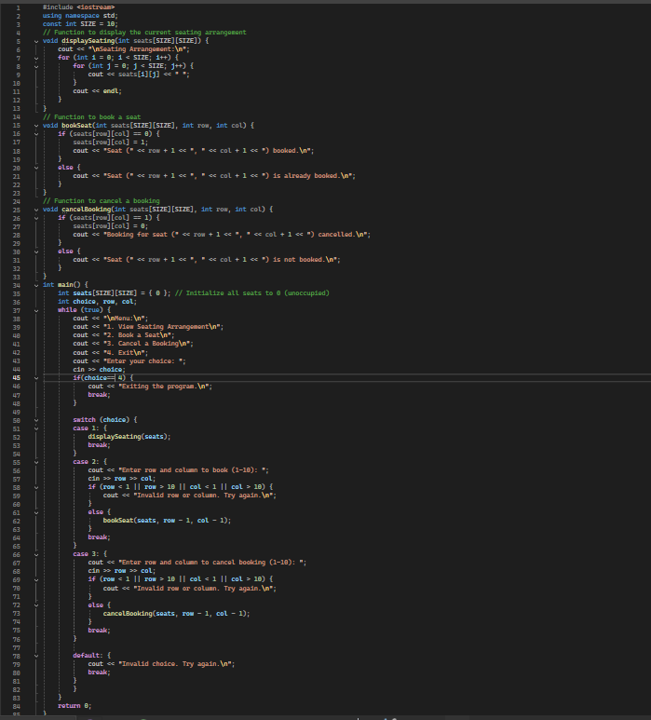

**Output:**

